CS 4470: Artificial Intelligence HW 2

Points: Please see the points for each problem. Instruction: Please submit on canvas

- Consider the minimax tree shown below for parts a and b.
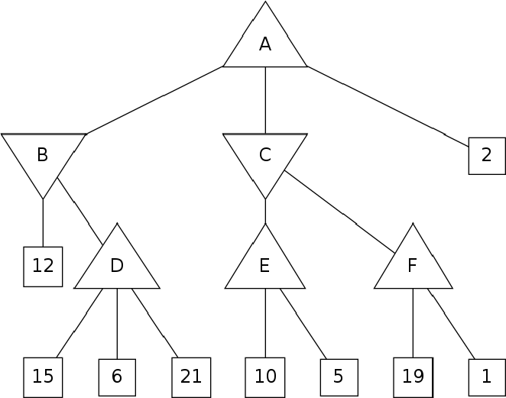

  - What value will root node A have? (4pts)
MAX(12, 10, 2) = 12

  - Cross off the nodes that are pruned by 𝛼𝛽 pruning. Assume the standard left-to-right traversal of the tree. If a non-terminal state (A, B, C, D, E, or F) is pruned, cross off the entire subtree. (4pts)
D -> PRUNE 6, 21, F -> PRUNE 1 = 6, 21, 1

- The following a-c refer to the environment below.
Pacman is using MDPs to maximize his expected utility. In each environment:
- Pacman has the standard actions {North, East, South, West} unless blocked by an outer wall. F is the goal state, so the only available action is TERMINATE.
- There is a reward of 1 point when eating the dot. For example, in the grid below, R([C, South, F] ) = 1)
- The game ends when the dot is eaten
Consider the following grid where there is a single food pellet in the bottom right corner F . The discount factor is 0.5. Living reward is 0. The states are simply the grid locations.

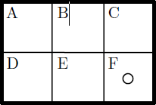

  - What is the optimal policy for each state A-F? (4pts)

Shortest path to F. E = E, C = S, B = E->C S->F, A = E->B E->C S->F, D = E->E E->F
So,
A = E, B = E, C = S, D = E, E = E, F = E

  - What is the optimal value 𝑉∗(𝐴) for state A? (4pts) V*(A) = ?
E->F=1, C->F = 1.
B = 0.5 X 1 = 0.5
D = 0.5 X 1 = 0.5
A-> F = 0.5 X 0.5 = 0.25

  - Using value iteration with the value of all states equal to zero at time 𝑘 = 0, at which time step 𝑘 will 𝑉_{𝑘}(𝐴) = 𝑉∗(𝐴)? (4pts)
k=?
It took 3 iterations to get to 0.25, so k = 3

